EE314 Experiment 3 Report

Your Name - Your Student Number

# 1.2.2

*fig 1 rtl schematic of decoder*

1.2.3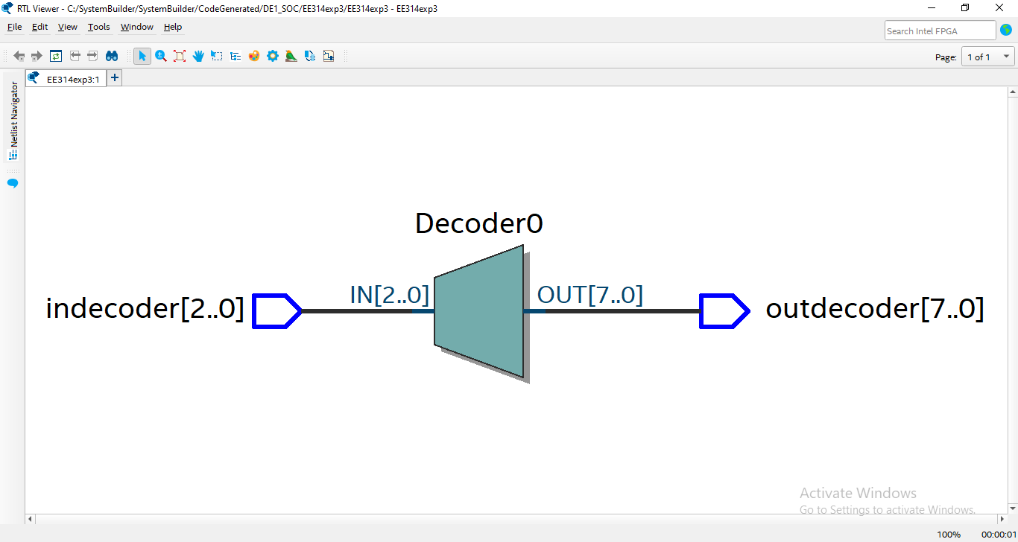

*fig 2 rtl schematic of decoder*

# 

# 1.2.4

*fig # figure name*

# 1.2.5

*fig # figure name*

*fig # figure name*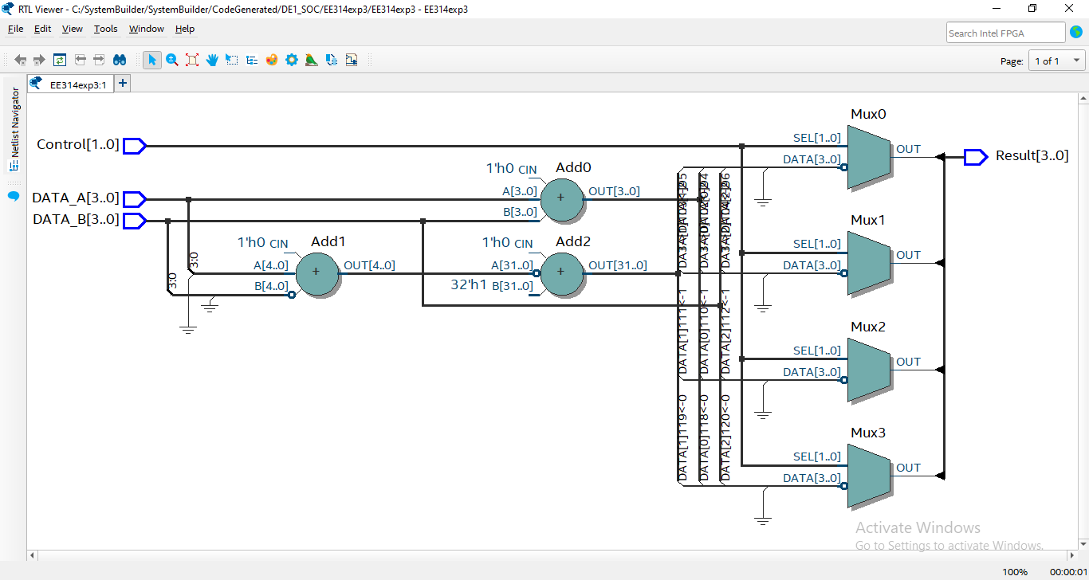

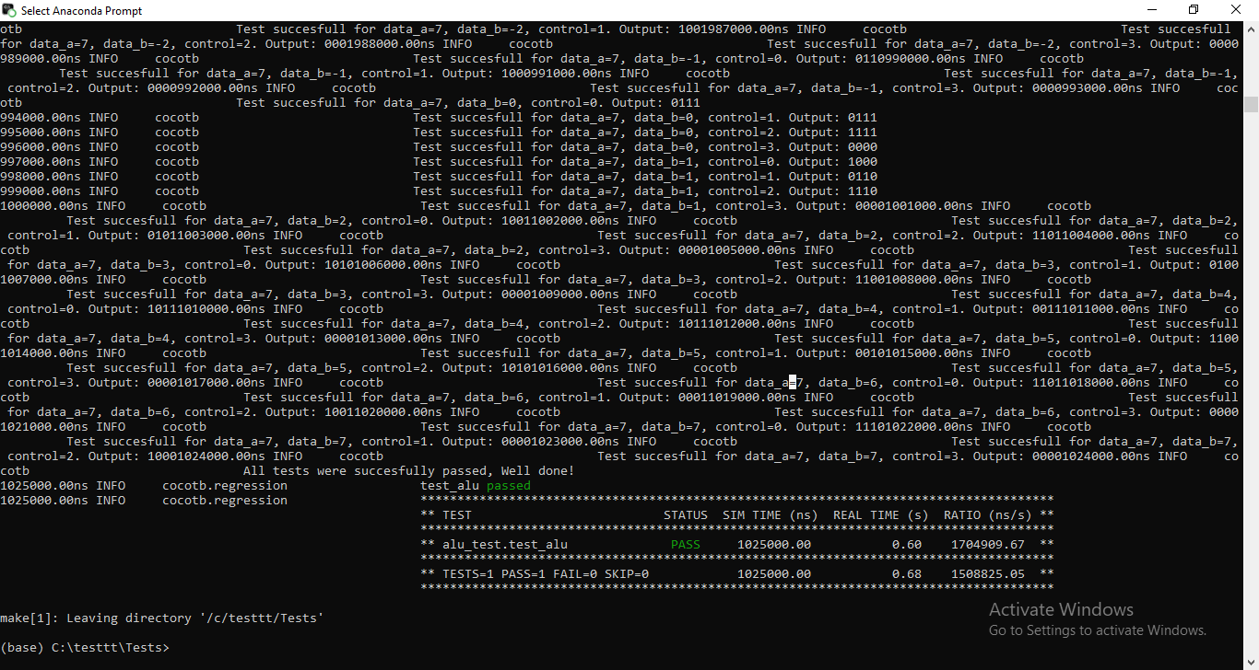

*fig # figure name*

# 1.3

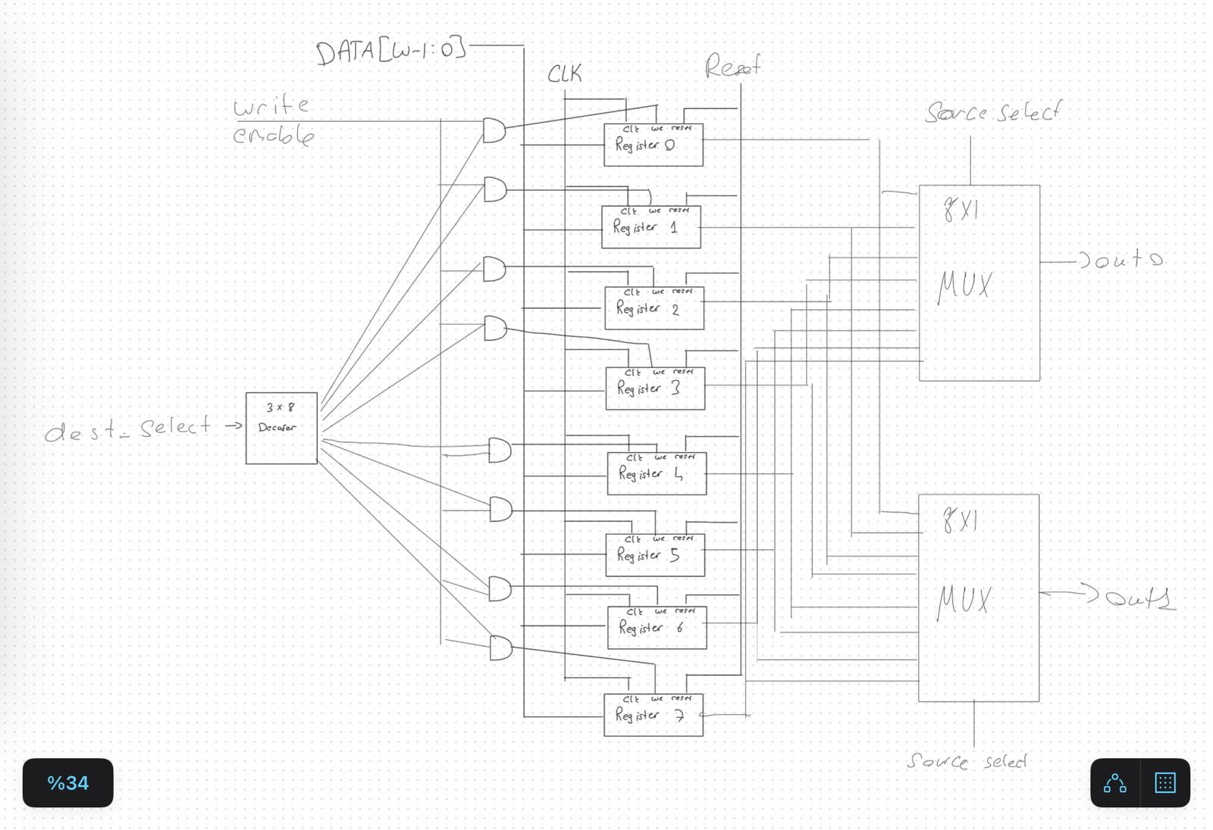

*fig # figure name*

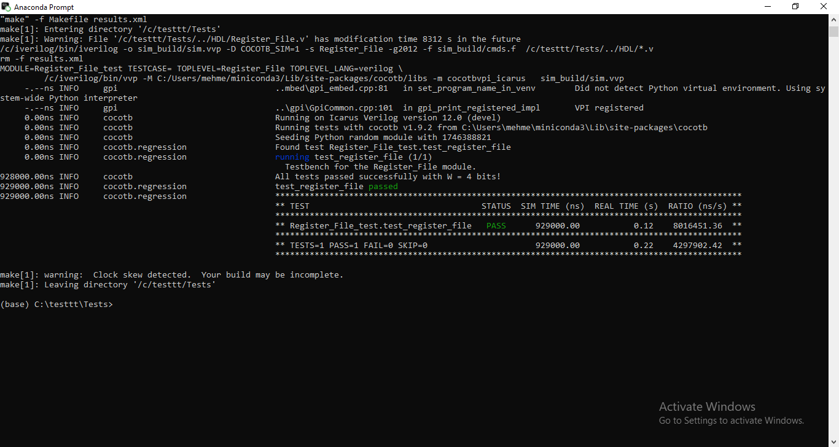

*fig # figure name*

**Appendix**

@cocotb.test()

async def test_alu(dut):

test_failed = False # Flag to track overall test failure

for Ain range(16):

A= A- 8

for B in range(16):

B = B - 8

for control in range(4):

dut.DATA_A.value = A

dut.DATA_B.value = B

dut.Control.value = control

await Timer(1, units='us')

if control == 0:

result = A+B

elif control == 1:

result = A - B

elif control == 2:

result = ~B

elif control == 3:

result = 0

result = result % 16

if dut.Result.value != result:

test_failed = True # Mark overall test as failed

cocotb.log.error(

f"Mismatch for data_a={A}, data_b={B}, control={control}: Expected {bin(result)[2:].zfill(4)}, "

f"Got {bin(dut.Result.value)[2:].zfill(4)}"

)

Log_Design(dut)

else:

cocotb.log.info(

f"Test succesfull for data_a={A}, data_b={B}, control={control}. Output: {dut.Result.value}")

# Final assertion for the overall result

if test_failed:

raise AssertionError("Some test cases failed. Check logs for details.")

else:

cocotb.log.info("All tests were succesfully passed, Well done!")